SALVI TUNNEL ENGINE
Informe Técnico de Iluminación de Túneles

Norma: CIE 88:2004 — Guide for the Lighting of Road Tunnels and Underpasses

Proyecto | Validacion informe
Tubo | T1
Longitud total | 300.0 m
Velocidad de diseño | 80.0 km/h
Tráfico de diseño | 500 veh/h
Clasificación óptica | optically long
Iluminación diurna | normal
Fecha del informe | 30/07/2026

Redactado con SALVI Tunnel Engine (STE) — Motor de cálculo conforme a CIE 88:2004.

1. Resumen de Validación

REVISAR — Existe al menos un criterio de perfil o de calidad fotométrica que no cumple.
Tubo / longitud | T1 / 300.0 m
Condición de diseño | 80.0 km/h · SD 140.0 m
Portal A | L20 4785.0 cd/m² · Lth 3.0 cd/m²
Portal B | L20 4785.0 cd/m² · Lth 0.0 cd/m²
Interior / noche | Lin 3.0 cd/m² · noche normal 3.0 cd/m² · noche reducida 1.0 cd/m²
Instalación calculada | 234 luminarias · 3.74 kW instalados
Condicionantes: Clase 1 OC 36/2015: no hay requisito de Lth; el perfil usa Lin únicamente como nivel de continuidad. · Lth=3.0 < 50 cd/m² (recomendado para v≥80 km/h) · 🔴🔴 CEX: ⚠️ U0_obj=0.4 NO ALCANZABLE a d=2.5m con ninguna optica+tilt (U0 resultante=0.308). Requiere reducir d.
2. Datos de Partida y Alcance

Geometría, tráfico y explotación

Longitud del tubo | 300.0 m
Calzada | 10.5 m · 2 carriles de 3.5 m
Sección / altura | Horseshoe · 5.5 m
Circulación | One Way
Velocidad / distancia de parada | 80.0 km/h · 140.0 m
Pendiente / fricción | 0 % · μ=None
Tráfico de proyecto | 500 veh/h
Pavimento | Asfalto Oscuro (R3)
Entorno y parámetros luminotécnicos

Método L20 / entorno | Model · Open Country Flat
Orientación / cielo | S · Clear
Portal A: L20 / Lth | 4785.0 / 3.0 cd/m²
Portal B: L20 / Lth | 4785.0 / 0.0 cd/m²
Factor de mantenimiento | 0.7
Reflectancias | Paredes ρ=0.4 · Techo ρ=—

3. Criterios y Metodología

- La luminancia de adaptación se determina para cada portal con el método L20. A partir de ella se obtiene la luminancia de umbral y el perfil longitudinal exigido según CIE 88:2004.
- El tubo se divide en zonas de umbral, transición e interior. Cuando hay circulación bidireccional, ambos portales se calculan de forma independiente y se conserva el caso más desfavorable en cada comprobación.
- La instalación se dimensiona con los ficheros fotométricos de las luminarias. La verificación se realiza sobre campos bidimensionales CIE 140:2019: luminancia media, uniformidad general U0, uniformidad longitudinal Ul e incremento de umbral TI.
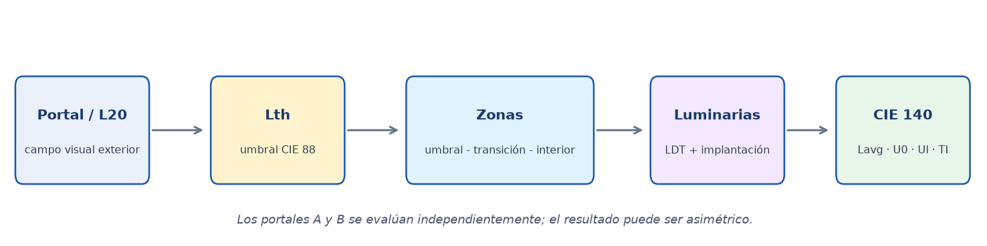
4. Resultado Luminotécnico — Perfil Longitudinal

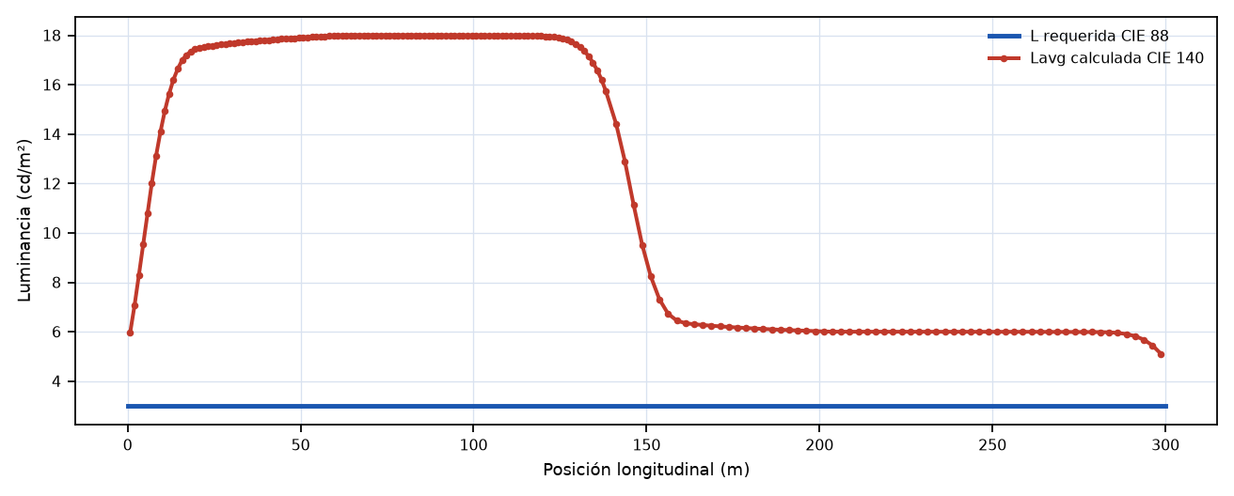
La curva roja procede exclusivamente de Lavg calculada en campos bidimensionales CIE 140 entre luminarias consecutivas.
Cumplimiento por zona

Zona | Lavg / Lreq | U0 | Ul | TI (%) | Estado
CTH | 5.97 / 3.0 | 0.441 | 0.791 | 7.8 | CUMPLE
BASE A–B | 5.1 / 3.0 | 0.447 | 0.855 | 16.4 | REVISAR

5. Diseño de la Instalación

Disposición | Central Single
Luminaria de referencia | Aphex APHEX_S_75W/Aphex S 75W 105mA 4000K
Óptica / CCT / I máx. | F2M2 · 4000K · 500 mA
Total instalado | 234 luminarias · 3.74 kW
Densidad media | 1.19 W/m²

Zona | Tramo (m) | Modelo / óptica | mA | W | d (m) | N | Tilt | Capa
BASE A–B | 0.0–300.0 | APHEX_S_75W / F2M2 | 105 | 16.0 | 2.5 | 122 | 0.0° | Permanent
CTH | 0.0–140.0 | APHEX_S_75W / F2M2 | 105 | 16.0 | 2.5 | 112 | 0.0° | Reinforcement
6. Plano de Implantación de Luminarias

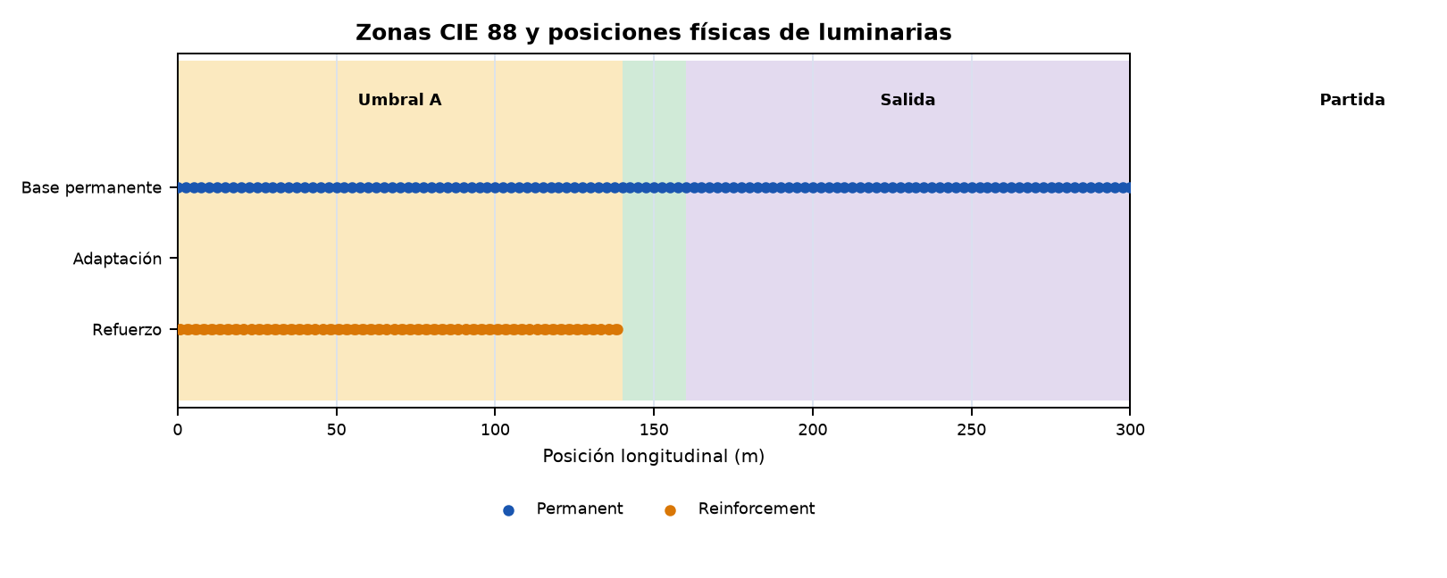
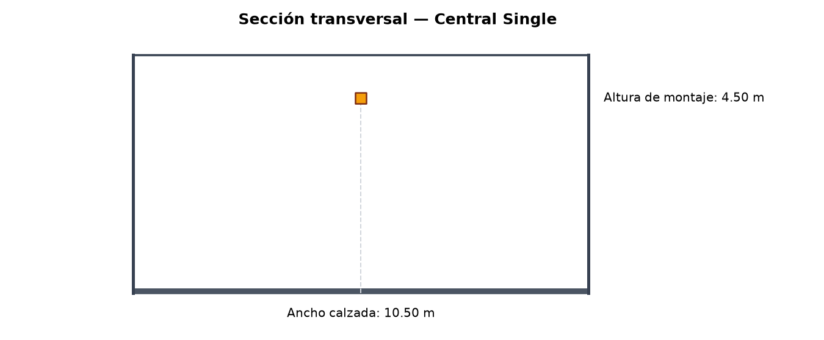
7. Control DALI y Escenas de Operación

Protocolo de control | DALI
Nº de grupos | 4
Nº de escenas | 6

Tabla de Regulación (grupos × escenas)

Grupo | L diseño  (cd/m²) | Soleado  L₂₀=4785 | Normal  L₂₀=3350 | Cubierto  L₂₀=1436 | Crepuscular  L₂₀=239 | Noche reducida  L₂₀=0 | Noche normal  L₂₀=0
BASE — Permanente A–B | 3.0 | 100.0%  DALI 254 | 100.0%  DALI 254 | 100.0%  DALI 254 | 100.0%  DALI 254 | 33.3%  DALI 214 | 100.0%  DALI 254
REF-A-TH — Umbral A | 0.0 | 0.0% | 0.0% | 0.0% | 0.0% | 0.0% | 0.0%
REF-A-TR1 — Transición A 1/2 | 0.0 | 0.0% | 0.0% | 0.0% | 0.0% | 0.0% | 0.0%
REF-A-TR2 — Transición A 2/2 | 0.0 | 0.0% | 0.0% | 0.0% | 0.0% | 0.0% | 0.0%
CTH=Umbral · CTRn=Transición · CIN=Interior · CEX=Salida. Niveles DALI según IEC 62386 (curva logarítmica, rango 0–254).
Potencia por escena de operación

Escena | Luminarias activas | Potencia (kW) | Flujo (lm)
Soleado | 122 | 1.952 | 405284.0
Noche | 122 | 1.948 | 405248.0
Soleado | 122 | 1.952 | 405284.0
Normal | 122 | 1.952 | 405284.0
Cubierto | 122 | 1.952 | 405284.0
Crepuscular | 122 | 1.952 | 405284.0
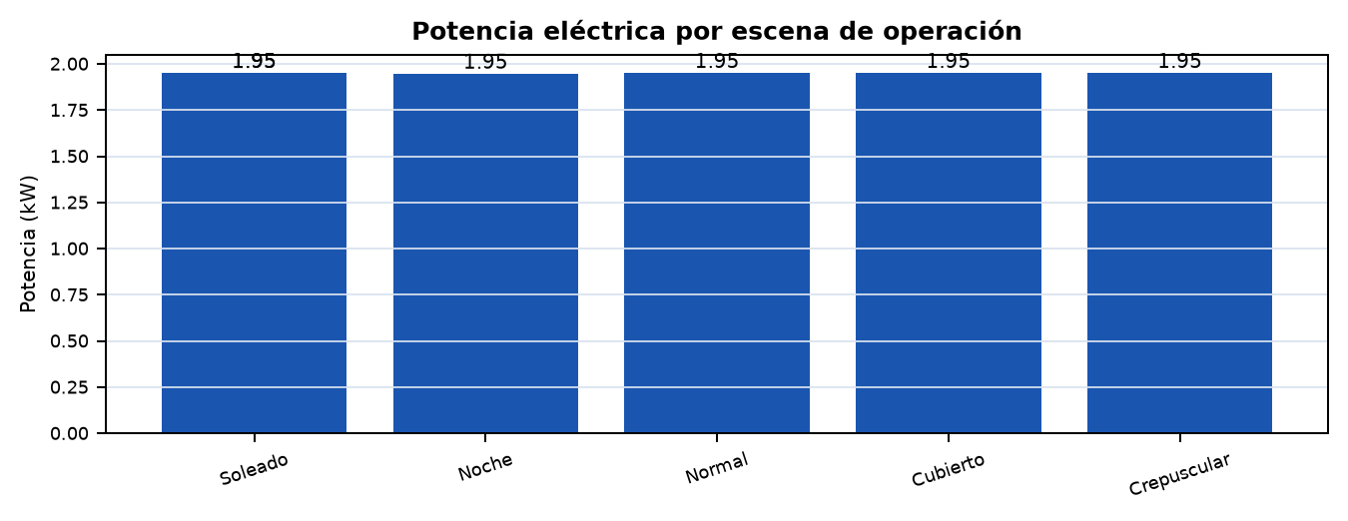
8. Potencia, Energía y Mantenimiento

Escena | Horas/año | Potencia (kW) | Consumo (kWh/año)
Soleado | 0 | 1.95 | 0
Noche | 0 | 1.95 | 0
Soleado | 1,200 | 1.95 | 2,342
Normal | 1,800 | 1.95 | 3,514
Cubierto | 900 | 1.95 | 1,757
Crepuscular | 600 | 1.95 | 1,171
TOTAL | 8,760 | — | 8,784
Coste anual de referencia: 1,318 EUR/año (tarifa 0.150 EUR/kWh; distribución anual de referencia escalada a 8,760 h/año).
Criterios de mantenimiento y explotación

Factor de mantenimiento aplicado | 0.7
Reflectancia de paredes | 0.4
Reflectancia de techo | 0.25
Revisión en recepción | Modelo/LDT, flujo, corriente, altura, posición, tilt, escenas DALI y mediciones finales.
9. Conclusiones y Verificaciones de Recepción

Estado del diseño: REVISAR. Existe al menos un criterio de perfil o de calidad fotométrica que no cumple.
- Verificar en obra la geometría efectiva, la posición transversal y la altura de montaje de cada fila.
- Comprobar que modelo, óptica, flujo, corriente y orientación/tilt coinciden con el listado de luminarias.
- Programar y ensayar las escenas y grupos DALI antes de la recepción de la instalación.
- Confirmar las condiciones de mantenimiento y las reflectancias adoptadas si difieren de las existentes en obra.

ANEXOS DE CÁLCULO E INSTALACIÓN

Los anexos conservan la trazabilidad necesaria para auditoría, dirección facultativa y puesta en marcha.
ANEXO A. Clasificación y Distancia de Parada

Clasificación geométrica | long
Clasificación óptica | optically long
Necesidad de ilum. diurna | normal
Distancia de parada (SD) | 140.0 m
Distancia de reacción (dr) | 33.3 m
Distancia de frenado (df) | 106.7 m
Justificación: Longitud: 300 m → long. Clasificación óptica: salida no visible desde SD=140 m, penetración de luz: poor → optically_long. Necesidad de iluminación diurna: normal.
ANEXO A.2 Datos L20, Lth e Interior

L₂₀ — Luminancia campo 20° | 4785.0 cd/m²
Método de cálculo L₂₀ | model
Confianza del valor L₂₀ | Media
Lth — Luminancia de umbral | 3.0 cd/m²
Factor k (Lth = k · L₂₀) | 0.0
Coef. revelación contraste qc | 0.1
Lseq — Luminancia equivalente | 4785.0 cd/m²
Lin — Luminancia interior | 3.0 cd/m²
L_noche normal | 3.0 cd/m²
L_noche reducida | 1.0 cd/m²
Nota L₂₀: Modelo entorno: open_country_flat, orientación: S, cielo: clear
ANEXO A.3 Zonas y Perfil Normativo

Zona | s inicio (m) | s fin (m) | Longitud (m) | L inicio (cd/m²) | L fin (cd/m²) | L mín. req. (cd/m²)
Acceso | -140.0 | 0.0 | 140.0 | 0.00 | 0.00 | 0.00
Umbral A | 0.0 | 140.0 | 140.0 | 3.00 | 3.00 | 3.00
Transición A | 140.0 | 140.0 | 0.0 | 3.00 | 3.00 | 3.00
Interior | 140.0 | 160.0 | 20.0 | 3.00 | 3.00 | 3.00
Salida | 160.0 | 300.0 | 140.0 | 3.00 | 0.00 | 1.50
Partida | 300.0 | 440.0 | 140.0 | 0.00 | 0.00 | 1.00
ANEXO B. Verificación Fotométrica CIE 140:2019

CIE 140:2019 · Tabla R3 · Optica F2M2 · H = 4.5 m
Zona | L_avg / L_req | U0 >=0.40 | Ul >=0.60 | TI <=15% | Estado
CTH | 5.97 / 3.0 | 0.441 | 0.791 | 7.8 | CUMPLE
BASE A–B | 5.1 / 3.0 | 0.447 | 0.855 | 16.4 | REVISAR

Verificación por carril y sentido

Zona | Carril | Sentido | L / Lreq | U0 carril* | Ul | TI | Estado
CTH | 1 | A → B | 4.751 / 3.0 | 0.5047 | 0.7914 | 5.131 | CUMPLE
CTH | 2 | A → B | 7.156 / 3.0 | 0.7028 | 0.8033 | 7.82 | CUMPLE
BASE A–B | 1 | A → B | 3.915 / 3.0 | 0.477 | 0.8546 | 10.764 | CUMPLE
BASE A–B | 2 | A → B | 5.67 / 3.0 | 0.6557 | 0.8628 | 16.398 | REVISAR
* U0 por carril es un diagnóstico adicional. La conformidad normativa de U0 se calcula sobre toda la calzada para cada observador; Ul se verifica sobre el eje de cada carril. En el resumen gobierna el peor resultado.

Criterio | Requisito | Estado
CIE 140:2019 global | todas las zonas | REVISAR
Perfil longitudinal normativo | CIE 88:2004 | CUMPLE
Ratios de transicion | <= 3:1 | CUMPLE

Advertencias del cálculo

- Clase 1 OC 36/2015: no hay requisito de Lth; el perfil usa Lin únicamente como nivel de continuidad.
- Lth=3.0 < 50 cd/m² (recomendado para v≥80 km/h)

ANEXO B.1. Campos CIE 140 — CTH

Campo (m) | Lavg | L req. | U0 | Ul | TI (%) | Caso gobernante
0.5–1.0 | 5.97 | — | 0.488 | 0.941 | 0.7 | C2 / A→B
1.0–3.0 | 7.06 | — | 0.443 | 0.791 | 0.6 | C2 / A→B
3.0–3.5 | 8.28 | — | 0.461 | 0.941 | 0.5 | C2 / A→B
3.5–5.5 | 9.53 | — | 0.425 | 0.832 | 0.5 | C2 / A→B
5.5–6.0 | 10.82 | — | 0.442 | 0.957 | 0.4 | C2 / A→B
6.0–8.0 | 12.02 | — | 0.416 | 0.881 | 0.4 | C2 / A→B
8.0–8.5 | 13.14 | — | 0.425 | 0.972 | 0.4 | C2 / A→B
8.5–10.5 | 14.10 | — | 0.408 | 0.924 | 0.3 | C2 / A→B
10.5–11.0 | 14.94 | — | 0.413 | 0.982 | 0.3 | C2 / A→B
11.0–13.0 | 15.64 | — | 0.403 | 0.951 | 0.3 | C2 / A→B
13.0–13.5 | 16.21 | — | 0.406 | 0.989 | 0.3 | C2 / A→B
13.5–15.5 | 16.65 | — | 0.399 | 0.972 | 0.3 | C2 / A→B
15.5–16.0 | 16.99 | — | 0.401 | 0.993 | 0.3 | C2 / A→B
16.0–18.0 | 17.20 | — | 0.399 | 0.989 | 0.3 | C2 / A→B
18.0–18.5 | 17.34 | — | 0.399 | 0.996 | 0.3 | C2 / A→B
18.5–20.5 | 17.44 | — | 0.399 | 0.996 | 0.3 | C2 / A→B
20.5–21.0 | 17.50 | — | 0.399 | 0.998 | 0.3 | C2 / A→B
21.0–23.0 | 17.54 | — | 0.399 | 0.997 | 0.3 | C2 / A→B
23.0–23.5 | 17.56 | — | 0.398 | 0.998 | 0.3 | C2 / A→B
23.5–25.5 | 17.59 | — | 0.399 | 0.997 | 0.3 | C2 / A→B
25.5–26.0 | 17.61 | — | 0.399 | 0.998 | 0.3 | C2 / A→B
26.0–28.0 | 17.63 | — | 0.400 | 0.997 | 0.3 | C2 / A→B
28.0–28.5 | 17.65 | — | 0.399 | 0.998 | 0.3 | C2 / A→B
28.5–30.5 | 17.67 | — | 0.400 | 0.997 | 0.3 | C2 / A→B
30.5–31.0 | 17.69 | — | 0.399 | 0.998 | 0.3 | C2 / A→B
31.0–33.0 | 17.71 | — | 0.400 | 0.997 | 0.3 | C2 / A→B
33.0–33.5 | 17.72 | — | 0.400 | 0.998 | 0.4 | C2 / A→B
33.5–35.5 | 17.74 | — | 0.401 | 0.997 | 0.4 | C2 / A→B
35.5–36.0 | 17.75 | — | 0.400 | 0.998 | 0.4 | C2 / A→B
36.0–38.0 | 17.77 | — | 0.401 | 0.997 | 0.4 | C2 / A→B
38.0–38.5 | 17.79 | — | 0.401 | 0.998 | 0.4 | C2 / A→B
38.5–40.5 | 17.80 | — | 0.402 | 0.997 | 0.5 | C2 / A→B
40.5–41.0 | 17.81 | — | 0.401 | 0.998 | 0.6 | C2 / A→B
41.0–43.0 | 17.83 | — | 0.402 | 0.996 | 0.7 | C2 / A→B
43.0–43.5 | 17.84 | — | 0.402 | 0.998 | 0.9 | C2 / A→B
43.5–45.5 | 17.86 | — | 0.403 | 0.996 | 1.1 | C2 / A→B
45.5–46.0 | 17.87 | — | 0.402 | 0.998 | 1.3 | C2 / A→B
46.0–48.0 | 17.88 | — | 0.403 | 0.996 | 1.5 | C2 / A→B
48.0–48.5 | 17.89 | — | 0.403 | 0.998 | 1.8 | C2 / A→B
48.5–50.5 | 17.90 | — | 0.404 | 0.996 | 2.1 | C2 / A→B
50.5–51.0 | 17.91 | — | 0.403 | 0.998 | 2.4 | C2 / A→B
51.0–53.0 | 17.92 | — | 0.405 | 0.996 | 2.6 | C2 / A→B
53.0–53.5 | 17.93 | — | 0.404 | 0.998 | 2.9 | C2 / A→B
53.5–55.5 | 17.94 | — | 0.405 | 0.996 | 3.1 | C2 / A→B
55.5–56.0 | 17.95 | — | 0.404 | 0.998 | 3.3 | C2 / A→B
56.0–58.0 | 17.96 | — | 0.406 | 0.996 | 3.5 | C2 / A→B
58.0–58.5 | 17.97 | — | 0.405 | 0.998 | 3.6 | C2 / A→B
58.5–60.5 | 17.98 | — | 0.406 | 0.996 | 3.8 | C2 / A→B
60.5–61.0 | 17.99 | — | 0.405 | 0.998 | 3.9 | C2 / A→B
61.0–63.0 | 18.00 | — | 0.407 | 0.996 | 4.1 | C2 / A→B
63.0–63.5 | 18.00 | — | 0.406 | 0.998 | 4.3 | C2 / A→B
63.5–65.5 | 18.01 | — | 0.406 | 0.995 | 4.6 | C2 / A→B
65.5–66.0 | 18.00 | — | 0.406 | 0.998 | 4.9 | C2 / A→B
66.0–68.0 | 18.01 | — | 0.406 | 0.995 | 5.1 | C2 / A→B
68.0–68.5 | 18.00 | — | 0.406 | 0.998 | 5.4 | C2 / A→B
68.5–70.5 | 18.01 | — | 0.406 | 0.995 | 5.7 | C2 / A→B
70.5–71.0 | 18.00 | — | 0.406 | 0.998 | 5.9 | C2 / A→B
71.0–73.0 | 18.01 | — | 0.406 | 0.995 | 6.2 | C2 / A→B
73.0–73.5 | 18.00 | — | 0.406 | 0.998 | 6.4 | C2 / A→B
73.5–75.5 | 18.01 | — | 0.406 | 0.995 | 6.5 | C2 / A→B
75.5–76.0 | 18.00 | — | 0.406 | 0.998 | 6.7 | C2 / A→B
76.0–78.0 | 18.00 | — | 0.406 | 0.995 | 6.8 | C2 / A→B
78.0–78.5 | 18.00 | — | 0.406 | 0.998 | 6.8 | C2 / A→B
78.5–80.5 | 18.00 | — | 0.406 | 0.995 | 6.9 | C2 / A→B
80.5–81.0 | 18.00 | — | 0.406 | 0.998 | 6.9 | C2 / A→B
81.0–83.0 | 18.00 | — | 0.406 | 0.995 | 6.9 | C2 / A→B
83.0–83.5 | 18.00 | — | 0.406 | 0.998 | 6.9 | C2 / A→B
83.5–85.5 | 18.00 | — | 0.406 | 0.995 | 6.9 | C2 / A→B
85.5–86.0 | 18.00 | — | 0.406 | 0.998 | 7.0 | C2 / A→B
86.0–88.0 | 18.00 | — | 0.406 | 0.995 | 7.0 | C2 / A→B
88.0–88.5 | 18.00 | — | 0.406 | 0.998 | 7.0 | C2 / A→B
88.5–90.5 | 18.00 | — | 0.406 | 0.995 | 7.0 | C2 / A→B
90.5–91.0 | 18.00 | — | 0.406 | 0.998 | 7.0 | C2 / A→B
91.0–93.0 | 18.00 | — | 0.406 | 0.995 | 7.0 | C2 / A→B
93.0–93.5 | 18.00 | — | 0.406 | 0.998 | 7.0 | C2 / A→B
93.5–95.5 | 18.00 | — | 0.406 | 0.995 | 7.0 | C2 / A→B
95.5–96.0 | 17.99 | — | 0.406 | 0.998 | 7.0 | C2 / A→B
96.0–98.0 | 18.00 | — | 0.406 | 0.995 | 7.0 | C2 / A→B
98.0–98.5 | 17.99 | — | 0.406 | 0.998 | 7.0 | C2 / A→B
98.5–100.5 | 18.00 | — | 0.406 | 0.995 | 7.0 | C2 / A→B
100.5–101.0 | 17.99 | — | 0.405 | 0.998 | 7.0 | C2 / A→B
101.0–103.0 | 18.00 | — | 0.406 | 0.995 | 7.0 | C2 / A→B
103.0–103.5 | 17.99 | — | 0.405 | 0.998 | 7.0 | C2 / A→B
103.5–105.5 | 17.99 | — | 0.406 | 0.995 | 7.0 | C2 / A→B
105.5–106.0 | 17.99 | — | 0.405 | 0.998 | 7.0 | C2 / A→B
106.0–108.0 | 17.99 | — | 0.406 | 0.995 | 7.0 | C2 / A→B
108.0–108.5 | 17.99 | — | 0.405 | 0.998 | 7.0 | C2 / A→B
108.5–110.5 | 17.99 | — | 0.406 | 0.995 | 7.0 | C2 / A→B
110.5–111.0 | 17.98 | — | 0.405 | 0.998 | 7.0 | C2 / A→B
111.0–113.0 | 17.99 | — | 0.406 | 0.995 | 7.0 | C2 / A→B
113.0–113.5 | 17.98 | — | 0.405 | 0.998 | 7.0 | C2 / A→B
113.5–115.5 | 17.99 | — | 0.406 | 0.995 | 7.0 | C2 / A→B
115.5–116.0 | 17.98 | — | 0.405 | 0.998 | 7.0 | C2 / A→B
116.0–118.0 | 17.98 | — | 0.406 | 0.995 | 7.0 | C2 / A→B
118.0–118.5 | 17.98 | — | 0.405 | 0.998 | 7.0 | C2 / A→B
118.5–120.5 | 17.98 | — | 0.406 | 0.995 | 7.0 | C2 / A→B
120.5–121.0 | 17.96 | — | 0.405 | 0.998 | 7.0 | C2 / A→B
121.0–123.0 | 17.96 | — | 0.405 | 0.995 | 7.0 | C2 / A→B
123.0–123.5 | 17.94 | — | 0.404 | 0.998 | 7.0 | C2 / A→B
123.5–125.5 | 17.91 | — | 0.404 | 0.993 | 7.0 | C2 / A→B
125.5–126.0 | 17.87 | — | 0.403 | 0.999 | 7.1 | C2 / A→B
126.0–128.0 | 17.82 | — | 0.402 | 0.991 | 7.1 | C2 / A→B
128.0–128.5 | 17.74 | — | 0.402 | 0.999 | 7.1 | C2 / A→B
128.5–130.5 | 17.65 | — | 0.399 | 0.987 | 7.1 | C2 / A→B
130.5–131.0 | 17.52 | — | 0.399 | 0.998 | 7.2 | C2 / A→B
131.0–133.0 | 17.37 | — | 0.394 | 0.980 | 7.2 | C2 / A→B
133.0–133.5 | 17.16 | — | 0.395 | 0.996 | 7.3 | C2 / A→B
133.5–135.5 | 16.90 | — | 0.386 | 0.968 | 7.4 | C2 / A→B
135.5–136.0 | 16.59 | — | 0.388 | 0.993 | 7.5 | C2 / A→B
136.0–138.0 | 16.21 | — | 0.378 | 0.958 | 7.6 | C2 / A→B
138.0–138.5 | 15.74 | — | 0.381 | 0.986 | 7.8 | C2 / A→B
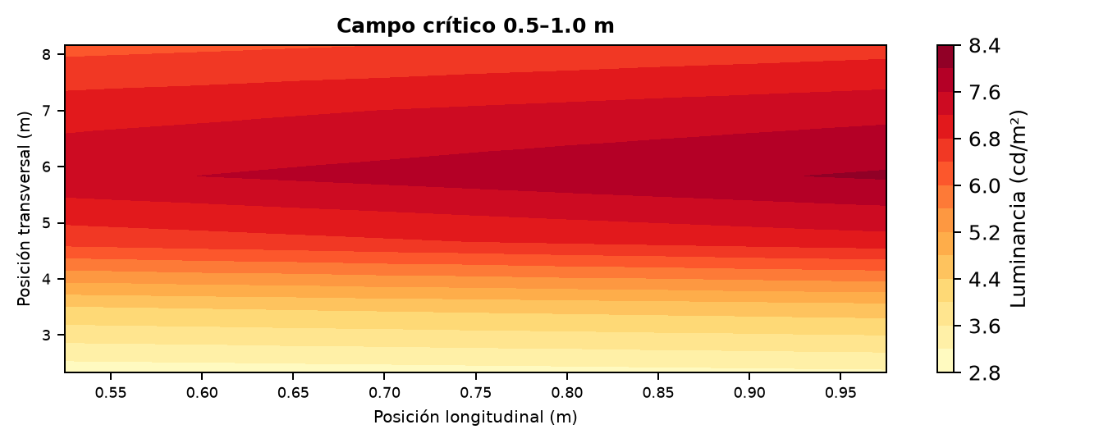

ANEXO B.2. Campos CIE 140 — BASE A–B

Campo (m) | Lavg | L req. | U0 | Ul | TI (%) | Caso gobernante
140.0–142.5 | 14.40 | — | 0.366 | 0.911 | 8.4 | C2 / A→B
142.5–145.0 | 12.91 | — | 0.356 | 0.878 | 9.2 | C2 / A→B
145.0–147.5 | 11.16 | — | 0.353 | 0.855 | 10.3 | C2 / A→B
147.5–150.0 | 9.52 | — | 0.360 | 0.872 | 11.7 | C2 / A→B
150.0–152.5 | 8.24 | — | 0.372 | 0.890 | 13.1 | C2 / A→B
152.5–155.0 | 7.31 | — | 0.388 | 0.914 | 14.4 | C2 / A→B
155.0–157.5 | 6.73 | — | 0.404 | 0.951 | 15.4 | C2 / A→B
157.5–160.0 | 6.46 | — | 0.412 | 0.976 | 15.9 | C2 / A→B
160.0–162.5 | 6.35 | — | 0.416 | 0.988 | 16.1 | C2 / A→B
162.5–165.0 | 6.30 | — | 0.417 | 0.990 | 16.2 | C2 / A→B
165.0–167.5 | 6.27 | — | 0.417 | 0.990 | 16.3 | C2 / A→B
167.5–170.0 | 6.24 | — | 0.416 | 0.990 | 16.3 | C2 / A→B
170.0–172.5 | 6.22 | — | 0.416 | 0.990 | 16.3 | C2 / A→B
172.5–175.0 | 6.19 | — | 0.415 | 0.990 | 16.4 | C2 / A→B
175.0–177.5 | 6.17 | — | 0.414 | 0.990 | 16.4 | C2 / A→B
177.5–180.0 | 6.15 | — | 0.413 | 0.990 | 16.4 | C2 / A→B
180.0–182.5 | 6.13 | — | 0.412 | 0.990 | 16.2 | C2 / A→B
182.5–185.0 | 6.11 | — | 0.411 | 0.990 | 15.9 | C2 / A→B
185.0–187.5 | 6.10 | — | 0.410 | 0.990 | 15.3 | C2 / A→B
187.5–190.0 | 6.08 | — | 0.409 | 0.991 | 14.5 | C2 / A→B
190.0–192.5 | 6.07 | — | 0.408 | 0.991 | 13.7 | C2 / A→B
192.5–195.0 | 6.05 | — | 0.407 | 0.991 | 12.8 | C2 / A→B
195.0–197.5 | 6.04 | — | 0.406 | 0.991 | 12.1 | C2 / A→B
197.5–200.0 | 6.03 | — | 0.405 | 0.991 | 11.6 | C2 / A→B
200.0–202.5 | 6.01 | — | 0.405 | 0.991 | 11.2 | C2 / A→B
202.5–205.0 | 6.00 | — | 0.404 | 0.991 | 10.6 | C2 / A→B
205.0–207.5 | 6.00 | — | 0.404 | 0.991 | 9.8 | C2 / A→B
207.5–210.0 | 6.00 | — | 0.404 | 0.991 | 8.8 | C2 / A→B
210.0–212.5 | 6.00 | — | 0.404 | 0.991 | 8.0 | C2 / A→B
212.5–215.0 | 6.00 | — | 0.404 | 0.991 | 7.2 | C2 / A→B
215.0–217.5 | 6.00 | — | 0.404 | 0.991 | 6.7 | C2 / A→B
217.5–220.0 | 6.00 | — | 0.404 | 0.991 | 6.4 | C2 / A→B
220.0–222.5 | 6.00 | — | 0.404 | 0.991 | 6.3 | C2 / A→B
222.5–225.0 | 6.00 | — | 0.404 | 0.991 | 6.2 | C2 / A→B
225.0–227.5 | 6.00 | — | 0.404 | 0.991 | 6.2 | C2 / A→B
227.5–230.0 | 6.00 | — | 0.404 | 0.991 | 6.2 | C2 / A→B
230.0–232.5 | 6.00 | — | 0.404 | 0.991 | 6.2 | C2 / A→B
232.5–235.0 | 6.00 | — | 0.404 | 0.991 | 6.2 | C2 / A→B
235.0–237.5 | 6.00 | — | 0.404 | 0.991 | 6.1 | C2 / A→B
237.5–240.0 | 6.00 | — | 0.404 | 0.991 | 6.1 | C2 / A→B
240.0–242.5 | 6.00 | — | 0.404 | 0.991 | 6.1 | C2 / A→B
242.5–245.0 | 6.00 | — | 0.404 | 0.991 | 6.1 | C2 / A→B
245.0–247.5 | 6.00 | — | 0.404 | 0.991 | 6.1 | C2 / A→B
247.5–250.0 | 6.00 | — | 0.404 | 0.991 | 6.1 | C2 / A→B
250.0–252.5 | 6.00 | — | 0.404 | 0.991 | 6.1 | C2 / A→B
252.5–255.0 | 6.00 | — | 0.404 | 0.991 | 6.1 | C2 / A→B
255.0–257.5 | 6.00 | — | 0.404 | 0.991 | 6.1 | C2 / A→B
257.5–260.0 | 6.00 | — | 0.404 | 0.991 | 6.1 | C2 / A→B
260.0–262.5 | 6.00 | — | 0.404 | 0.991 | 6.1 | C2 / A→B
262.5–265.0 | 6.00 | — | 0.404 | 0.991 | 6.1 | C2 / A→B
265.0–267.5 | 6.00 | — | 0.404 | 0.991 | 6.1 | C2 / A→B
267.5–270.0 | 6.00 | — | 0.403 | 0.991 | 6.1 | C2 / A→B
270.0–272.5 | 5.99 | — | 0.403 | 0.991 | 6.1 | C2 / A→B
272.5–275.0 | 5.99 | — | 0.403 | 0.991 | 6.1 | C2 / A→B
275.0–277.5 | 5.99 | — | 0.403 | 0.991 | 6.1 | C2 / A→B
277.5–280.0 | 5.99 | — | 0.403 | 0.991 | 6.1 | C2 / A→B
280.0–282.5 | 5.99 | — | 0.403 | 0.990 | 6.1 | C2 / A→B
282.5–285.0 | 5.98 | — | 0.402 | 0.989 | 6.1 | C2 / A→B
285.0–287.5 | 5.95 | — | 0.400 | 0.987 | 6.1 | C2 / A→B
287.5–290.0 | 5.91 | — | 0.397 | 0.983 | 6.1 | C2 / A→B
290.0–292.5 | 5.82 | — | 0.392 | 0.976 | 6.2 | C2 / A→B
292.5–295.0 | 5.68 | — | 0.383 | 0.964 | 6.3 | C2 / A→B
295.0–297.5 | 5.45 | — | 0.370 | 0.941 | 6.5 | C2 / A→B
297.5–300.0 | 5.10 | — | 0.354 | 0.918 | 6.9 | C2 / A→B
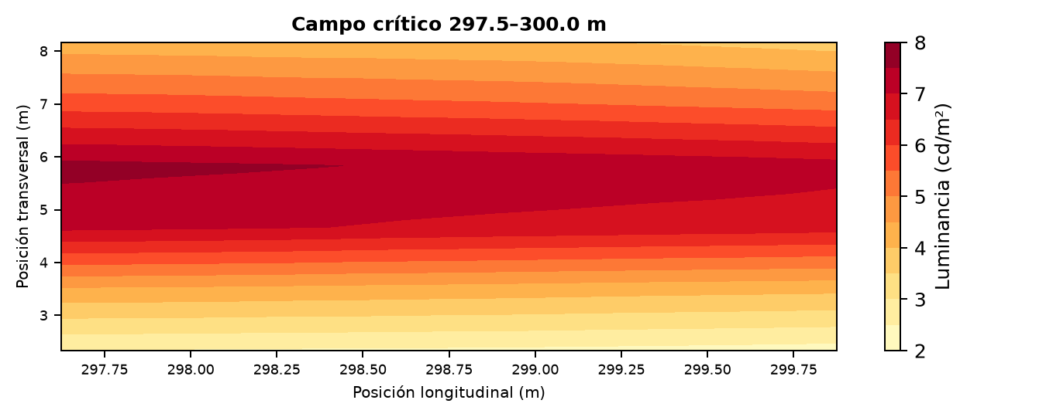

ANEXO C. Listado de Luminarias y Reglajes

Listado por posición longitudinal. Las coordenadas transversales y la configuración de filas se rigen por la disposición indicada en el informe principal.
Ref. | Zona | PK (m) | Modelo | Óptica | mA | W | Tilt | Capa
BASE A–B-1 | BASE A–B | -2.5 | APHEX_S_75W | F2M2 | 105.0 | 16.0 | 0.0° | Permanent
BASE A–B-2 | BASE A–B | 0.0 | APHEX_S_75W | F2M2 | 105.0 | 16.0 | 0.0° | Permanent
BASE A–B-3 | BASE A–B | 2.5 | APHEX_S_75W | F2M2 | 105.0 | 16.0 | 0.0° | Permanent
BASE A–B-4 | BASE A–B | 5.0 | APHEX_S_75W | F2M2 | 105.0 | 16.0 | 0.0° | Permanent
BASE A–B-5 | BASE A–B | 7.5 | APHEX_S_75W | F2M2 | 105.0 | 16.0 | 0.0° | Permanent
BASE A–B-6 | BASE A–B | 10.0 | APHEX_S_75W | F2M2 | 105.0 | 16.0 | 0.0° | Permanent
BASE A–B-7 | BASE A–B | 12.5 | APHEX_S_75W | F2M2 | 105.0 | 16.0 | 0.0° | Permanent
BASE A–B-8 | BASE A–B | 15.0 | APHEX_S_75W | F2M2 | 105.0 | 16.0 | 0.0° | Permanent
BASE A–B-9 | BASE A–B | 17.5 | APHEX_S_75W | F2M2 | 105.0 | 16.0 | 0.0° | Permanent
BASE A–B-10 | BASE A–B | 20.0 | APHEX_S_75W | F2M2 | 105.0 | 16.0 | 0.0° | Permanent
BASE A–B-11 | BASE A–B | 22.5 | APHEX_S_75W | F2M2 | 105.0 | 16.0 | 0.0° | Permanent
BASE A–B-12 | BASE A–B | 25.0 | APHEX_S_75W | F2M2 | 105.0 | 16.0 | 0.0° | Permanent
BASE A–B-13 | BASE A–B | 27.5 | APHEX_S_75W | F2M2 | 105.0 | 16.0 | 0.0° | Permanent
BASE A–B-14 | BASE A–B | 30.0 | APHEX_S_75W | F2M2 | 105.0 | 16.0 | 0.0° | Permanent
BASE A–B-15 | BASE A–B | 32.5 | APHEX_S_75W | F2M2 | 105.0 | 16.0 | 0.0° | Permanent
BASE A–B-16 | BASE A–B | 35.0 | APHEX_S_75W | F2M2 | 105.0 | 16.0 | 0.0° | Permanent
BASE A–B-17 | BASE A–B | 37.5 | APHEX_S_75W | F2M2 | 105.0 | 16.0 | 0.0° | Permanent
BASE A–B-18 | BASE A–B | 40.0 | APHEX_S_75W | F2M2 | 105.0 | 16.0 | 0.0° | Permanent
BASE A–B-19 | BASE A–B | 42.5 | APHEX_S_75W | F2M2 | 105.0 | 16.0 | 0.0° | Permanent
BASE A–B-20 | BASE A–B | 45.0 | APHEX_S_75W | F2M2 | 105.0 | 16.0 | 0.0° | Permanent
BASE A–B-21 | BASE A–B | 47.5 | APHEX_S_75W | F2M2 | 105.0 | 16.0 | 0.0° | Permanent
BASE A–B-22 | BASE A–B | 50.0 | APHEX_S_75W | F2M2 | 105.0 | 16.0 | 0.0° | Permanent
BASE A–B-23 | BASE A–B | 52.5 | APHEX_S_75W | F2M2 | 105.0 | 16.0 | 0.0° | Permanent
BASE A–B-24 | BASE A–B | 55.0 | APHEX_S_75W | F2M2 | 105.0 | 16.0 | 0.0° | Permanent
BASE A–B-25 | BASE A–B | 57.5 | APHEX_S_75W | F2M2 | 105.0 | 16.0 | 0.0° | Permanent
BASE A–B-26 | BASE A–B | 60.0 | APHEX_S_75W | F2M2 | 105.0 | 16.0 | 0.0° | Permanent
BASE A–B-27 | BASE A–B | 62.5 | APHEX_S_75W | F2M2 | 105.0 | 16.0 | 0.0° | Permanent
BASE A–B-28 | BASE A–B | 65.0 | APHEX_S_75W | F2M2 | 105.0 | 16.0 | 0.0° | Permanent
BASE A–B-29 | BASE A–B | 67.5 | APHEX_S_75W | F2M2 | 105.0 | 16.0 | 0.0° | Permanent
BASE A–B-30 | BASE A–B | 70.0 | APHEX_S_75W | F2M2 | 105.0 | 16.0 | 0.0° | Permanent
BASE A–B-31 | BASE A–B | 72.5 | APHEX_S_75W | F2M2 | 105.0 | 16.0 | 0.0° | Permanent
BASE A–B-32 | BASE A–B | 75.0 | APHEX_S_75W | F2M2 | 105.0 | 16.0 | 0.0° | Permanent
BASE A–B-33 | BASE A–B | 77.5 | APHEX_S_75W | F2M2 | 105.0 | 16.0 | 0.0° | Permanent
BASE A–B-34 | BASE A–B | 80.0 | APHEX_S_75W | F2M2 | 105.0 | 16.0 | 0.0° | Permanent
BASE A–B-35 | BASE A–B | 82.5 | APHEX_S_75W | F2M2 | 105.0 | 16.0 | 0.0° | Permanent
BASE A–B-36 | BASE A–B | 85.0 | APHEX_S_75W | F2M2 | 105.0 | 16.0 | 0.0° | Permanent
BASE A–B-37 | BASE A–B | 87.5 | APHEX_S_75W | F2M2 | 105.0 | 16.0 | 0.0° | Permanent
BASE A–B-38 | BASE A–B | 90.0 | APHEX_S_75W | F2M2 | 105.0 | 16.0 | 0.0° | Permanent
BASE A–B-39 | BASE A–B | 92.5 | APHEX_S_75W | F2M2 | 105.0 | 16.0 | 0.0° | Permanent
BASE A–B-40 | BASE A–B | 95.0 | APHEX_S_75W | F2M2 | 105.0 | 16.0 | 0.0° | Permanent
BASE A–B-41 | BASE A–B | 97.5 | APHEX_S_75W | F2M2 | 105.0 | 16.0 | 0.0° | Permanent
BASE A–B-42 | BASE A–B | 100.0 | APHEX_S_75W | F2M2 | 105.0 | 16.0 | 0.0° | Permanent
BASE A–B-43 | BASE A–B | 102.5 | APHEX_S_75W | F2M2 | 105.0 | 16.0 | 0.0° | Permanent
BASE A–B-44 | BASE A–B | 105.0 | APHEX_S_75W | F2M2 | 105.0 | 16.0 | 0.0° | Permanent
BASE A–B-45 | BASE A–B | 107.5 | APHEX_S_75W | F2M2 | 105.0 | 16.0 | 0.0° | Permanent
BASE A–B-46 | BASE A–B | 110.0 | APHEX_S_75W | F2M2 | 105.0 | 16.0 | 0.0° | Permanent
BASE A–B-47 | BASE A–B | 112.5 | APHEX_S_75W | F2M2 | 105.0 | 16.0 | 0.0° | Permanent
BASE A–B-48 | BASE A–B | 115.0 | APHEX_S_75W | F2M2 | 105.0 | 16.0 | 0.0° | Permanent
BASE A–B-49 | BASE A–B | 117.5 | APHEX_S_75W | F2M2 | 105.0 | 16.0 | 0.0° | Permanent
BASE A–B-50 | BASE A–B | 120.0 | APHEX_S_75W | F2M2 | 105.0 | 16.0 | 0.0° | Permanent
BASE A–B-51 | BASE A–B | 122.5 | APHEX_S_75W | F2M2 | 105.0 | 16.0 | 0.0° | Permanent
BASE A–B-52 | BASE A–B | 125.0 | APHEX_S_75W | F2M2 | 105.0 | 16.0 | 0.0° | Permanent
BASE A–B-53 | BASE A–B | 127.5 | APHEX_S_75W | F2M2 | 105.0 | 16.0 | 0.0° | Permanent
BASE A–B-54 | BASE A–B | 130.0 | APHEX_S_75W | F2M2 | 105.0 | 16.0 | 0.0° | Permanent
BASE A–B-55 | BASE A–B | 132.5 | APHEX_S_75W | F2M2 | 105.0 | 16.0 | 0.0° | Permanent
BASE A–B-56 | BASE A–B | 135.0 | APHEX_S_75W | F2M2 | 105.0 | 16.0 | 0.0° | Permanent
BASE A–B-57 | BASE A–B | 137.5 | APHEX_S_75W | F2M2 | 105.0 | 16.0 | 0.0° | Permanent
BASE A–B-58 | BASE A–B | 140.0 | APHEX_S_75W | F2M2 | 105.0 | 16.0 | 0.0° | Permanent
BASE A–B-59 | BASE A–B | 142.5 | APHEX_S_75W | F2M2 | 105.0 | 16.0 | 0.0° | Permanent
BASE A–B-60 | BASE A–B | 145.0 | APHEX_S_75W | F2M2 | 105.0 | 16.0 | 0.0° | Permanent
BASE A–B-61 | BASE A–B | 147.5 | APHEX_S_75W | F2M2 | 105.0 | 16.0 | 0.0° | Permanent
BASE A–B-62 | BASE A–B | 150.0 | APHEX_S_75W | F2M2 | 105.0 | 16.0 | 0.0° | Permanent
BASE A–B-63 | BASE A–B | 152.5 | APHEX_S_75W | F2M2 | 105.0 | 16.0 | 0.0° | Permanent
BASE A–B-64 | BASE A–B | 155.0 | APHEX_S_75W | F2M2 | 105.0 | 16.0 | 0.0° | Permanent
BASE A–B-65 | BASE A–B | 157.5 | APHEX_S_75W | F2M2 | 105.0 | 16.0 | 0.0° | Permanent
BASE A–B-66 | BASE A–B | 160.0 | APHEX_S_75W | F2M2 | 105.0 | 16.0 | 0.0° | Permanent
BASE A–B-67 | BASE A–B | 162.5 | APHEX_S_75W | F2M2 | 105.0 | 16.0 | 0.0° | Permanent
BASE A–B-68 | BASE A–B | 165.0 | APHEX_S_75W | F2M2 | 105.0 | 16.0 | 0.0° | Permanent
BASE A–B-69 | BASE A–B | 167.5 | APHEX_S_75W | F2M2 | 105.0 | 16.0 | 0.0° | Permanent
BASE A–B-70 | BASE A–B | 170.0 | APHEX_S_75W | F2M2 | 105.0 | 16.0 | 0.0° | Permanent
BASE A–B-71 | BASE A–B | 172.5 | APHEX_S_75W | F2M2 | 105.0 | 16.0 | 0.0° | Permanent
BASE A–B-72 | BASE A–B | 175.0 | APHEX_S_75W | F2M2 | 105.0 | 16.0 | 0.0° | Permanent
BASE A–B-73 | BASE A–B | 177.5 | APHEX_S_75W | F2M2 | 105.0 | 16.0 | 0.0° | Permanent
BASE A–B-74 | BASE A–B | 180.0 | APHEX_S_75W | F2M2 | 105.0 | 16.0 | 0.0° | Permanent
BASE A–B-75 | BASE A–B | 182.5 | APHEX_S_75W | F2M2 | 105.0 | 16.0 | 0.0° | Permanent
BASE A–B-76 | BASE A–B | 185.0 | APHEX_S_75W | F2M2 | 105.0 | 16.0 | 0.0° | Permanent
BASE A–B-77 | BASE A–B | 187.5 | APHEX_S_75W | F2M2 | 105.0 | 16.0 | 0.0° | Permanent
BASE A–B-78 | BASE A–B | 190.0 | APHEX_S_75W | F2M2 | 105.0 | 16.0 | 0.0° | Permanent
BASE A–B-79 | BASE A–B | 192.5 | APHEX_S_75W | F2M2 | 105.0 | 16.0 | 0.0° | Permanent
BASE A–B-80 | BASE A–B | 195.0 | APHEX_S_75W | F2M2 | 105.0 | 16.0 | 0.0° | Permanent
BASE A–B-81 | BASE A–B | 197.5 | APHEX_S_75W | F2M2 | 105.0 | 16.0 | 0.0° | Permanent
BASE A–B-82 | BASE A–B | 200.0 | APHEX_S_75W | F2M2 | 105.0 | 16.0 | 0.0° | Permanent
BASE A–B-83 | BASE A–B | 202.5 | APHEX_S_75W | F2M2 | 105.0 | 16.0 | 0.0° | Permanent
BASE A–B-84 | BASE A–B | 205.0 | APHEX_S_75W | F2M2 | 105.0 | 16.0 | 0.0° | Permanent
BASE A–B-85 | BASE A–B | 207.5 | APHEX_S_75W | F2M2 | 105.0 | 16.0 | 0.0° | Permanent
BASE A–B-86 | BASE A–B | 210.0 | APHEX_S_75W | F2M2 | 105.0 | 16.0 | 0.0° | Permanent
BASE A–B-87 | BASE A–B | 212.5 | APHEX_S_75W | F2M2 | 105.0 | 16.0 | 0.0° | Permanent
BASE A–B-88 | BASE A–B | 215.0 | APHEX_S_75W | F2M2 | 105.0 | 16.0 | 0.0° | Permanent
BASE A–B-89 | BASE A–B | 217.5 | APHEX_S_75W | F2M2 | 105.0 | 16.0 | 0.0° | Permanent
BASE A–B-90 | BASE A–B | 220.0 | APHEX_S_75W | F2M2 | 105.0 | 16.0 | 0.0° | Permanent
BASE A–B-91 | BASE A–B | 222.5 | APHEX_S_75W | F2M2 | 105.0 | 16.0 | 0.0° | Permanent
BASE A–B-92 | BASE A–B | 225.0 | APHEX_S_75W | F2M2 | 105.0 | 16.0 | 0.0° | Permanent
BASE A–B-93 | BASE A–B | 227.5 | APHEX_S_75W | F2M2 | 105.0 | 16.0 | 0.0° | Permanent
BASE A–B-94 | BASE A–B | 230.0 | APHEX_S_75W | F2M2 | 105.0 | 16.0 | 0.0° | Permanent
BASE A–B-95 | BASE A–B | 232.5 | APHEX_S_75W | F2M2 | 105.0 | 16.0 | 0.0° | Permanent
BASE A–B-96 | BASE A–B | 235.0 | APHEX_S_75W | F2M2 | 105.0 | 16.0 | 0.0° | Permanent
BASE A–B-97 | BASE A–B | 237.5 | APHEX_S_75W | F2M2 | 105.0 | 16.0 | 0.0° | Permanent
BASE A–B-98 | BASE A–B | 240.0 | APHEX_S_75W | F2M2 | 105.0 | 16.0 | 0.0° | Permanent
BASE A–B-99 | BASE A–B | 242.5 | APHEX_S_75W | F2M2 | 105.0 | 16.0 | 0.0° | Permanent
BASE A–B-100 | BASE A–B | 245.0 | APHEX_S_75W | F2M2 | 105.0 | 16.0 | 0.0° | Permanent
BASE A–B-101 | BASE A–B | 247.5 | APHEX_S_75W | F2M2 | 105.0 | 16.0 | 0.0° | Permanent
BASE A–B-102 | BASE A–B | 250.0 | APHEX_S_75W | F2M2 | 105.0 | 16.0 | 0.0° | Permanent
BASE A–B-103 | BASE A–B | 252.5 | APHEX_S_75W | F2M2 | 105.0 | 16.0 | 0.0° | Permanent
BASE A–B-104 | BASE A–B | 255.0 | APHEX_S_75W | F2M2 | 105.0 | 16.0 | 0.0° | Permanent
BASE A–B-105 | BASE A–B | 257.5 | APHEX_S_75W | F2M2 | 105.0 | 16.0 | 0.0° | Permanent
BASE A–B-106 | BASE A–B | 260.0 | APHEX_S_75W | F2M2 | 105.0 | 16.0 | 0.0° | Permanent
BASE A–B-107 | BASE A–B | 262.5 | APHEX_S_75W | F2M2 | 105.0 | 16.0 | 0.0° | Permanent
BASE A–B-108 | BASE A–B | 265.0 | APHEX_S_75W | F2M2 | 105.0 | 16.0 | 0.0° | Permanent
BASE A–B-109 | BASE A–B | 267.5 | APHEX_S_75W | F2M2 | 105.0 | 16.0 | 0.0° | Permanent
BASE A–B-110 | BASE A–B | 270.0 | APHEX_S_75W | F2M2 | 105.0 | 16.0 | 0.0° | Permanent
BASE A–B-111 | BASE A–B | 272.5 | APHEX_S_75W | F2M2 | 105.0 | 16.0 | 0.0° | Permanent
BASE A–B-112 | BASE A–B | 275.0 | APHEX_S_75W | F2M2 | 105.0 | 16.0 | 0.0° | Permanent
BASE A–B-113 | BASE A–B | 277.5 | APHEX_S_75W | F2M2 | 105.0 | 16.0 | 0.0° | Permanent
BASE A–B-114 | BASE A–B | 280.0 | APHEX_S_75W | F2M2 | 105.0 | 16.0 | 0.0° | Permanent
BASE A–B-115 | BASE A–B | 282.5 | APHEX_S_75W | F2M2 | 105.0 | 16.0 | 0.0° | Permanent
BASE A–B-116 | BASE A–B | 285.0 | APHEX_S_75W | F2M2 | 105.0 | 16.0 | 0.0° | Permanent
BASE A–B-117 | BASE A–B | 287.5 | APHEX_S_75W | F2M2 | 105.0 | 16.0 | 0.0° | Permanent
BASE A–B-118 | BASE A–B | 290.0 | APHEX_S_75W | F2M2 | 105.0 | 16.0 | 0.0° | Permanent
BASE A–B-119 | BASE A–B | 292.5 | APHEX_S_75W | F2M2 | 105.0 | 16.0 | 0.0° | Permanent
BASE A–B-120 | BASE A–B | 295.0 | APHEX_S_75W | F2M2 | 105.0 | 16.0 | 0.0° | Permanent
BASE A–B-121 | BASE A–B | 297.5 | APHEX_S_75W | F2M2 | 105.0 | 16.0 | 0.0° | Permanent
BASE A–B-122 | BASE A–B | 300.0 | APHEX_S_75W | F2M2 | 105.0 | 16.0 | 0.0° | Permanent
CTH-1 | CTH | 0.5 | APHEX_S_75W | F2M2 | 105.0 | 16.0 | 0.0° | Reinforcement
CTH-2 | CTH | 1.0 | APHEX_S_75W | F2M2 | 105.0 | 16.0 | 0.0° | Reinforcement
CTH-3 | CTH | 3.0 | APHEX_S_75W | F2M2 | 105.0 | 16.0 | 0.0° | Reinforcement
CTH-4 | CTH | 3.5 | APHEX_S_75W | F2M2 | 105.0 | 16.0 | 0.0° | Reinforcement
CTH-5 | CTH | 5.5 | APHEX_S_75W | F2M2 | 105.0 | 16.0 | 0.0° | Reinforcement
CTH-6 | CTH | 6.0 | APHEX_S_75W | F2M2 | 105.0 | 16.0 | 0.0° | Reinforcement
CTH-7 | CTH | 8.0 | APHEX_S_75W | F2M2 | 105.0 | 16.0 | 0.0° | Reinforcement
CTH-8 | CTH | 8.5 | APHEX_S_75W | F2M2 | 105.0 | 16.0 | 0.0° | Reinforcement
CTH-9 | CTH | 10.5 | APHEX_S_75W | F2M2 | 105.0 | 16.0 | 0.0° | Reinforcement
CTH-10 | CTH | 11.0 | APHEX_S_75W | F2M2 | 105.0 | 16.0 | 0.0° | Reinforcement
CTH-11 | CTH | 13.0 | APHEX_S_75W | F2M2 | 105.0 | 16.0 | 0.0° | Reinforcement
CTH-12 | CTH | 13.5 | APHEX_S_75W | F2M2 | 105.0 | 16.0 | 0.0° | Reinforcement
CTH-13 | CTH | 15.5 | APHEX_S_75W | F2M2 | 105.0 | 16.0 | 0.0° | Reinforcement
CTH-14 | CTH | 16.0 | APHEX_S_75W | F2M2 | 105.0 | 16.0 | 0.0° | Reinforcement
CTH-15 | CTH | 18.0 | APHEX_S_75W | F2M2 | 105.0 | 16.0 | 0.0° | Reinforcement
CTH-16 | CTH | 18.5 | APHEX_S_75W | F2M2 | 105.0 | 16.0 | 0.0° | Reinforcement
CTH-17 | CTH | 20.5 | APHEX_S_75W | F2M2 | 105.0 | 16.0 | 0.0° | Reinforcement
CTH-18 | CTH | 21.0 | APHEX_S_75W | F2M2 | 105.0 | 16.0 | 0.0° | Reinforcement
CTH-19 | CTH | 23.0 | APHEX_S_75W | F2M2 | 105.0 | 16.0 | 0.0° | Reinforcement
CTH-20 | CTH | 23.5 | APHEX_S_75W | F2M2 | 105.0 | 16.0 | 0.0° | Reinforcement
CTH-21 | CTH | 25.5 | APHEX_S_75W | F2M2 | 105.0 | 16.0 | 0.0° | Reinforcement
CTH-22 | CTH | 26.0 | APHEX_S_75W | F2M2 | 105.0 | 16.0 | 0.0° | Reinforcement
CTH-23 | CTH | 28.0 | APHEX_S_75W | F2M2 | 105.0 | 16.0 | 0.0° | Reinforcement
CTH-24 | CTH | 28.5 | APHEX_S_75W | F2M2 | 105.0 | 16.0 | 0.0° | Reinforcement
CTH-25 | CTH | 30.5 | APHEX_S_75W | F2M2 | 105.0 | 16.0 | 0.0° | Reinforcement
CTH-26 | CTH | 31.0 | APHEX_S_75W | F2M2 | 105.0 | 16.0 | 0.0° | Reinforcement
CTH-27 | CTH | 33.0 | APHEX_S_75W | F2M2 | 105.0 | 16.0 | 0.0° | Reinforcement
CTH-28 | CTH | 33.5 | APHEX_S_75W | F2M2 | 105.0 | 16.0 | 0.0° | Reinforcement
CTH-29 | CTH | 35.5 | APHEX_S_75W | F2M2 | 105.0 | 16.0 | 0.0° | Reinforcement
CTH-30 | CTH | 36.0 | APHEX_S_75W | F2M2 | 105.0 | 16.0 | 0.0° | Reinforcement
CTH-31 | CTH | 38.0 | APHEX_S_75W | F2M2 | 105.0 | 16.0 | 0.0° | Reinforcement
CTH-32 | CTH | 38.5 | APHEX_S_75W | F2M2 | 105.0 | 16.0 | 0.0° | Reinforcement
CTH-33 | CTH | 40.5 | APHEX_S_75W | F2M2 | 105.0 | 16.0 | 0.0° | Reinforcement
CTH-34 | CTH | 41.0 | APHEX_S_75W | F2M2 | 105.0 | 16.0 | 0.0° | Reinforcement
CTH-35 | CTH | 43.0 | APHEX_S_75W | F2M2 | 105.0 | 16.0 | 0.0° | Reinforcement
CTH-36 | CTH | 43.5 | APHEX_S_75W | F2M2 | 105.0 | 16.0 | 0.0° | Reinforcement
CTH-37 | CTH | 45.5 | APHEX_S_75W | F2M2 | 105.0 | 16.0 | 0.0° | Reinforcement
CTH-38 | CTH | 46.0 | APHEX_S_75W | F2M2 | 105.0 | 16.0 | 0.0° | Reinforcement
CTH-39 | CTH | 48.0 | APHEX_S_75W | F2M2 | 105.0 | 16.0 | 0.0° | Reinforcement
CTH-40 | CTH | 48.5 | APHEX_S_75W | F2M2 | 105.0 | 16.0 | 0.0° | Reinforcement
CTH-41 | CTH | 50.5 | APHEX_S_75W | F2M2 | 105.0 | 16.0 | 0.0° | Reinforcement
CTH-42 | CTH | 51.0 | APHEX_S_75W | F2M2 | 105.0 | 16.0 | 0.0° | Reinforcement
CTH-43 | CTH | 53.0 | APHEX_S_75W | F2M2 | 105.0 | 16.0 | 0.0° | Reinforcement
CTH-44 | CTH | 53.5 | APHEX_S_75W | F2M2 | 105.0 | 16.0 | 0.0° | Reinforcement
CTH-45 | CTH | 55.5 | APHEX_S_75W | F2M2 | 105.0 | 16.0 | 0.0° | Reinforcement
CTH-46 | CTH | 56.0 | APHEX_S_75W | F2M2 | 105.0 | 16.0 | 0.0° | Reinforcement
CTH-47 | CTH | 58.0 | APHEX_S_75W | F2M2 | 105.0 | 16.0 | 0.0° | Reinforcement
CTH-48 | CTH | 58.5 | APHEX_S_75W | F2M2 | 105.0 | 16.0 | 0.0° | Reinforcement
CTH-49 | CTH | 60.5 | APHEX_S_75W | F2M2 | 105.0 | 16.0 | 0.0° | Reinforcement
CTH-50 | CTH | 61.0 | APHEX_S_75W | F2M2 | 105.0 | 16.0 | 0.0° | Reinforcement
CTH-51 | CTH | 63.0 | APHEX_S_75W | F2M2 | 105.0 | 16.0 | 0.0° | Reinforcement
CTH-52 | CTH | 63.5 | APHEX_S_75W | F2M2 | 105.0 | 16.0 | 0.0° | Reinforcement
CTH-53 | CTH | 65.5 | APHEX_S_75W | F2M2 | 105.0 | 16.0 | 0.0° | Reinforcement
CTH-54 | CTH | 66.0 | APHEX_S_75W | F2M2 | 105.0 | 16.0 | 0.0° | Reinforcement
CTH-55 | CTH | 68.0 | APHEX_S_75W | F2M2 | 105.0 | 16.0 | 0.0° | Reinforcement
CTH-56 | CTH | 68.5 | APHEX_S_75W | F2M2 | 105.0 | 16.0 | 0.0° | Reinforcement
CTH-57 | CTH | 70.5 | APHEX_S_75W | F2M2 | 105.0 | 16.0 | 0.0° | Reinforcement
CTH-58 | CTH | 71.0 | APHEX_S_75W | F2M2 | 105.0 | 16.0 | 0.0° | Reinforcement
CTH-59 | CTH | 73.0 | APHEX_S_75W | F2M2 | 105.0 | 16.0 | 0.0° | Reinforcement
CTH-60 | CTH | 73.5 | APHEX_S_75W | F2M2 | 105.0 | 16.0 | 0.0° | Reinforcement
CTH-61 | CTH | 75.5 | APHEX_S_75W | F2M2 | 105.0 | 16.0 | 0.0° | Reinforcement
CTH-62 | CTH | 76.0 | APHEX_S_75W | F2M2 | 105.0 | 16.0 | 0.0° | Reinforcement
CTH-63 | CTH | 78.0 | APHEX_S_75W | F2M2 | 105.0 | 16.0 | 0.0° | Reinforcement
CTH-64 | CTH | 78.5 | APHEX_S_75W | F2M2 | 105.0 | 16.0 | 0.0° | Reinforcement
CTH-65 | CTH | 80.5 | APHEX_S_75W | F2M2 | 105.0 | 16.0 | 0.0° | Reinforcement
CTH-66 | CTH | 81.0 | APHEX_S_75W | F2M2 | 105.0 | 16.0 | 0.0° | Reinforcement
CTH-67 | CTH | 83.0 | APHEX_S_75W | F2M2 | 105.0 | 16.0 | 0.0° | Reinforcement
CTH-68 | CTH | 83.5 | APHEX_S_75W | F2M2 | 105.0 | 16.0 | 0.0° | Reinforcement
CTH-69 | CTH | 85.5 | APHEX_S_75W | F2M2 | 105.0 | 16.0 | 0.0° | Reinforcement
CTH-70 | CTH | 86.0 | APHEX_S_75W | F2M2 | 105.0 | 16.0 | 0.0° | Reinforcement
CTH-71 | CTH | 88.0 | APHEX_S_75W | F2M2 | 105.0 | 16.0 | 0.0° | Reinforcement
CTH-72 | CTH | 88.5 | APHEX_S_75W | F2M2 | 105.0 | 16.0 | 0.0° | Reinforcement
CTH-73 | CTH | 90.5 | APHEX_S_75W | F2M2 | 105.0 | 16.0 | 0.0° | Reinforcement
CTH-74 | CTH | 91.0 | APHEX_S_75W | F2M2 | 105.0 | 16.0 | 0.0° | Reinforcement
CTH-75 | CTH | 93.0 | APHEX_S_75W | F2M2 | 105.0 | 16.0 | 0.0° | Reinforcement
CTH-76 | CTH | 93.5 | APHEX_S_75W | F2M2 | 105.0 | 16.0 | 0.0° | Reinforcement
CTH-77 | CTH | 95.5 | APHEX_S_75W | F2M2 | 105.0 | 16.0 | 0.0° | Reinforcement
CTH-78 | CTH | 96.0 | APHEX_S_75W | F2M2 | 105.0 | 16.0 | 0.0° | Reinforcement
CTH-79 | CTH | 98.0 | APHEX_S_75W | F2M2 | 105.0 | 16.0 | 0.0° | Reinforcement
CTH-80 | CTH | 98.5 | APHEX_S_75W | F2M2 | 105.0 | 16.0 | 0.0° | Reinforcement
CTH-81 | CTH | 100.5 | APHEX_S_75W | F2M2 | 105.0 | 16.0 | 0.0° | Reinforcement
CTH-82 | CTH | 101.0 | APHEX_S_75W | F2M2 | 105.0 | 16.0 | 0.0° | Reinforcement
CTH-83 | CTH | 103.0 | APHEX_S_75W | F2M2 | 105.0 | 16.0 | 0.0° | Reinforcement
CTH-84 | CTH | 103.5 | APHEX_S_75W | F2M2 | 105.0 | 16.0 | 0.0° | Reinforcement
CTH-85 | CTH | 105.5 | APHEX_S_75W | F2M2 | 105.0 | 16.0 | 0.0° | Reinforcement
CTH-86 | CTH | 106.0 | APHEX_S_75W | F2M2 | 105.0 | 16.0 | 0.0° | Reinforcement
CTH-87 | CTH | 108.0 | APHEX_S_75W | F2M2 | 105.0 | 16.0 | 0.0° | Reinforcement
CTH-88 | CTH | 108.5 | APHEX_S_75W | F2M2 | 105.0 | 16.0 | 0.0° | Reinforcement
CTH-89 | CTH | 110.5 | APHEX_S_75W | F2M2 | 105.0 | 16.0 | 0.0° | Reinforcement
CTH-90 | CTH | 111.0 | APHEX_S_75W | F2M2 | 105.0 | 16.0 | 0.0° | Reinforcement
CTH-91 | CTH | 113.0 | APHEX_S_75W | F2M2 | 105.0 | 16.0 | 0.0° | Reinforcement
CTH-92 | CTH | 113.5 | APHEX_S_75W | F2M2 | 105.0 | 16.0 | 0.0° | Reinforcement
CTH-93 | CTH | 115.5 | APHEX_S_75W | F2M2 | 105.0 | 16.0 | 0.0° | Reinforcement
CTH-94 | CTH | 116.0 | APHEX_S_75W | F2M2 | 105.0 | 16.0 | 0.0° | Reinforcement
CTH-95 | CTH | 118.0 | APHEX_S_75W | F2M2 | 105.0 | 16.0 | 0.0° | Reinforcement
CTH-96 | CTH | 118.5 | APHEX_S_75W | F2M2 | 105.0 | 16.0 | 0.0° | Reinforcement
CTH-97 | CTH | 120.5 | APHEX_S_75W | F2M2 | 105.0 | 16.0 | 0.0° | Reinforcement
CTH-98 | CTH | 121.0 | APHEX_S_75W | F2M2 | 105.0 | 16.0 | 0.0° | Reinforcement
CTH-99 | CTH | 123.0 | APHEX_S_75W | F2M2 | 105.0 | 16.0 | 0.0° | Reinforcement
CTH-100 | CTH | 123.5 | APHEX_S_75W | F2M2 | 105.0 | 16.0 | 0.0° | Reinforcement
CTH-101 | CTH | 125.5 | APHEX_S_75W | F2M2 | 105.0 | 16.0 | 0.0° | Reinforcement
CTH-102 | CTH | 126.0 | APHEX_S_75W | F2M2 | 105.0 | 16.0 | 0.0° | Reinforcement
CTH-103 | CTH | 128.0 | APHEX_S_75W | F2M2 | 105.0 | 16.0 | 0.0° | Reinforcement
CTH-104 | CTH | 128.5 | APHEX_S_75W | F2M2 | 105.0 | 16.0 | 0.0° | Reinforcement
CTH-105 | CTH | 130.5 | APHEX_S_75W | F2M2 | 105.0 | 16.0 | 0.0° | Reinforcement
CTH-106 | CTH | 131.0 | APHEX_S_75W | F2M2 | 105.0 | 16.0 | 0.0° | Reinforcement
CTH-107 | CTH | 133.0 | APHEX_S_75W | F2M2 | 105.0 | 16.0 | 0.0° | Reinforcement
CTH-108 | CTH | 133.5 | APHEX_S_75W | F2M2 | 105.0 | 16.0 | 0.0° | Reinforcement
CTH-109 | CTH | 135.5 | APHEX_S_75W | F2M2 | 105.0 | 16.0 | 0.0° | Reinforcement
CTH-110 | CTH | 136.0 | APHEX_S_75W | F2M2 | 105.0 | 16.0 | 0.0° | Reinforcement
CTH-111 | CTH | 138.0 | APHEX_S_75W | F2M2 | 105.0 | 16.0 | 0.0° | Reinforcement
CTH-112 | CTH | 138.5 | APHEX_S_75W | F2M2 | 105.0 | 16.0 | 0.0° | Reinforcement

